3111 Hilton St. NW BOARD OF TRUSTEES
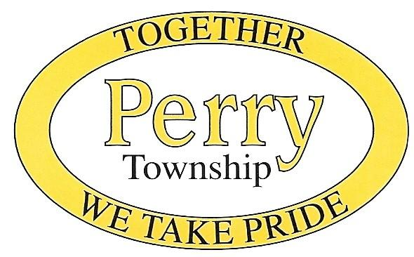
Massillon, Ohio 44646 Matt B. Miller
Phone: (330) 833-2141 Lisa J. Nelligan
Fax: (330) 833-2153 Ralph R. DeChiara, Jr.

www.perrytwp.com FISCAL OFFICER
office@perrytwp.com Craig E. Chessler
Law Director, James F. Mathews Fire Chief, Larry S. Sedlock Police Chief, Bryan D. Taylor
Public Works Director, John Wellman Township Administrator, Gerrie Cotter Zoning Inspector, Jeff S. Whytsell

This is to inform you that the Perry Township Board of Zoning Appeals will hold a Regular Meeting at the Perry Township Administration Office located at 3111 Hilton St N.W., Massillon, Ohio 44646 on Monday April 6, 2026 at 6:00 PM.

The following appeal case will be heard:
Case 04-26A Douglas Powell, 3411 Genoa Ave SW, Canton, OH 44706
Parcel #4306778
The applicant is seeking size and setback variances for a detached garage on a residential parcel. Section 602.4 Accessory Buildings, Uses and Structures.

Case 04-26B Thomas Austin & Tina Wilkens, 3162 Genoa Ave SW, Canton, OH 44706
Parcel #4306029
The applicant is seeking size and setback variances for a detached garage on a residential parcel. Section 602.4 Accessory Structures, Uses and Buildings.

The maps and proposed applications will be available for examination starting Monday March 23, 2026, by appointment at the Perry Township Zoning Department. This meeting is open to the public.

